  
  
  
CS 319 - Object-Oriented Software Engineering  
Design Report   
Second Iteration  
  
  
Project Name: Survival in Bilkent

Group 2-M

Pelin Elbin Günay - 21402149

Kübra Nur Güzel - 21400946

Alper Şahıstan - 21501207

Semih Teker– 21300964

Table of Contents

**1. Introduction** 3

**1.1.** **Purpose of the system** 3

**1.2 Design Goals** 3

End User Criteria: 3

Maintenance Criteria: 3

Performance Criteria: 3

Trade-Offs: 4

**1.3 Definitions, acronyms, and abbreviations** 4

**2. Software Architecture** 5

**2.1** **Subsystem Decomposition** 5

**2.2** **Hardware / Software Mapping** 7

**2.3** **Persistent Data Management** 7

**2.4** **Boundary Condition** 8

**3** **Subsystem Services** 8

**3.1** **Detailed Object Design** 8

**3.2** **User Interface Subsystem** 9

**3.3 Upgrade Management Subsystem** 11

**3.4 Level Manager Subsystem** 15

**3.5** **Game Logic Subsystem** 19

**3.6** **Game Screen Elements Subsystem** 26

**3.7 Game Entities Package** 30

# **1. Introduction**

## **Purpose of the system**

Survival in Bilkent is a top to down 2D shooter game. The purpose of the game is to entertain the player. In order to design more enjoyable game, we created a variety of enemies such as bugs, assignments, quizzes, labs, midterms, and finals. These are the obstacles that the players shoot. Additionally, we designed our game that includes 4 levels. These levels’ difficulty increases from first to the last level. Because of that, the game is more enjoyable and challenging.

## **1.2 Design Goals**

### End User Criteria:

**User-Friendliness:** The game can be played easily. In other words, the mechanics are generic and self-explanatory that seen in many 2-D shooter games. Additionally, we create an understandable user interface.

### Maintenance Criteria:

**Extensibility:** Reusability and extendibility are crucial for software projects. Especially, we will add new upgrade items to the project. In addition, Survival in Bilkent can be modified and re-used in another project easily.

**Portability:** Our game will work in different software environments and we will implement our project in Java because it has JVM that provides an opportunity to work correctly.

### Performance Criteria:

**Game Performance**: The game should move instantly. Average FPS should be greater than 30. Otherwise, the game cannot be playable and enjoyable.

### Trade-Offs:

**Performance vs. Memory**: Performance is important for our games. We want our game will run quickly. In order to move our game smoothly, we should increase the memory space to give better game experience.

**Efficiency – Reusability:** We indicated that our game will be reusable. We will try to write the code as much reusable we can. However, if the game’s efficiency is affected in a bad way, we will try to write the code more efficiently rather than reusability.

## **1.3 Definitions, acronyms, and abbreviations**

MVC: Model View Controller

JDK: JavaDevelopment Kit

JVM: Java Virtual Machine

FPS: frames per second

# **2. Software Architecture**

## **Subsystem Decomposition**

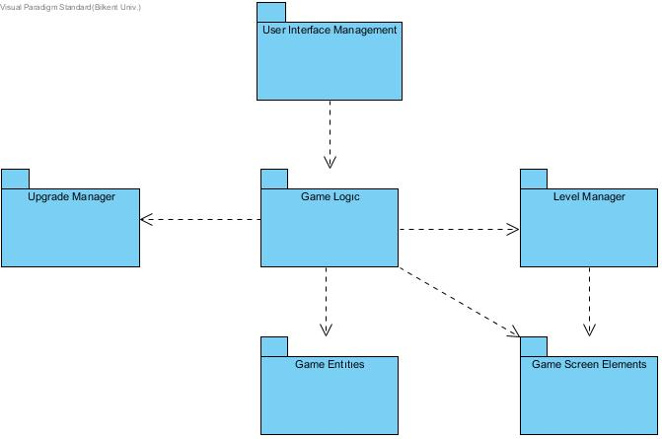We choose to construct a three-tier architectural decomposition for our projects system because it is the most suitable option for this game. Subsystem decomposition includes User Interface Management, Game Logic, Upgrade Manager, Level Manager, Game Entities, and Game Screen Elements.

Subsystem Decomposition

In the first layer, presentation layer, we have classes responsible for presenting the interface to the user. Those classes will create the bridge between the user and the game system. In the User Interface Subsystem, there will be classes called Menu and Screen Manager, where Menu is the first interaction the user will come across. After the choices user makes, these options will be passed to the Game Logic subsystem.

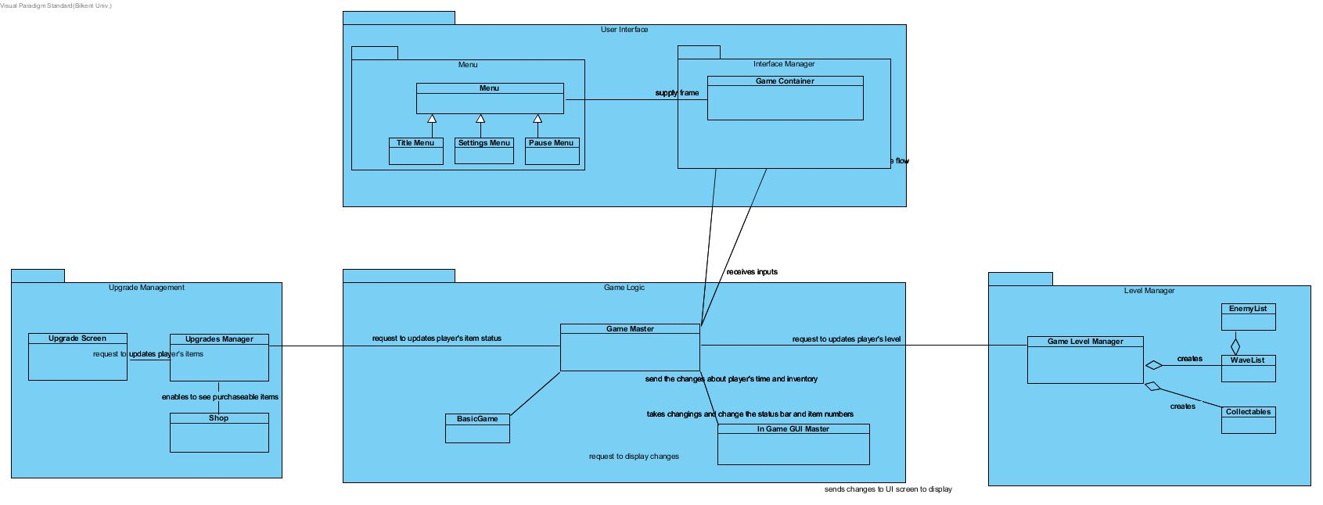

In the logic layer which is the second layer of the subsystem, choices that user made in the first layer will be evaluated in the Game Logic subsystem. For example, if the user chooses the “Start Game” option, it will be constructed by the Game Masterclass. Also in this layer, Game Logic is in full association with Upgrade Manager and Level Manager subsystem. Level Manager is responsible for creating the layouts of the levels, then passing the created level to the Game Logic. This subsystem will update the information that passed to the Game Logic continuously due to the results of game objects.

Relation Between Layer 1 and Layer 2

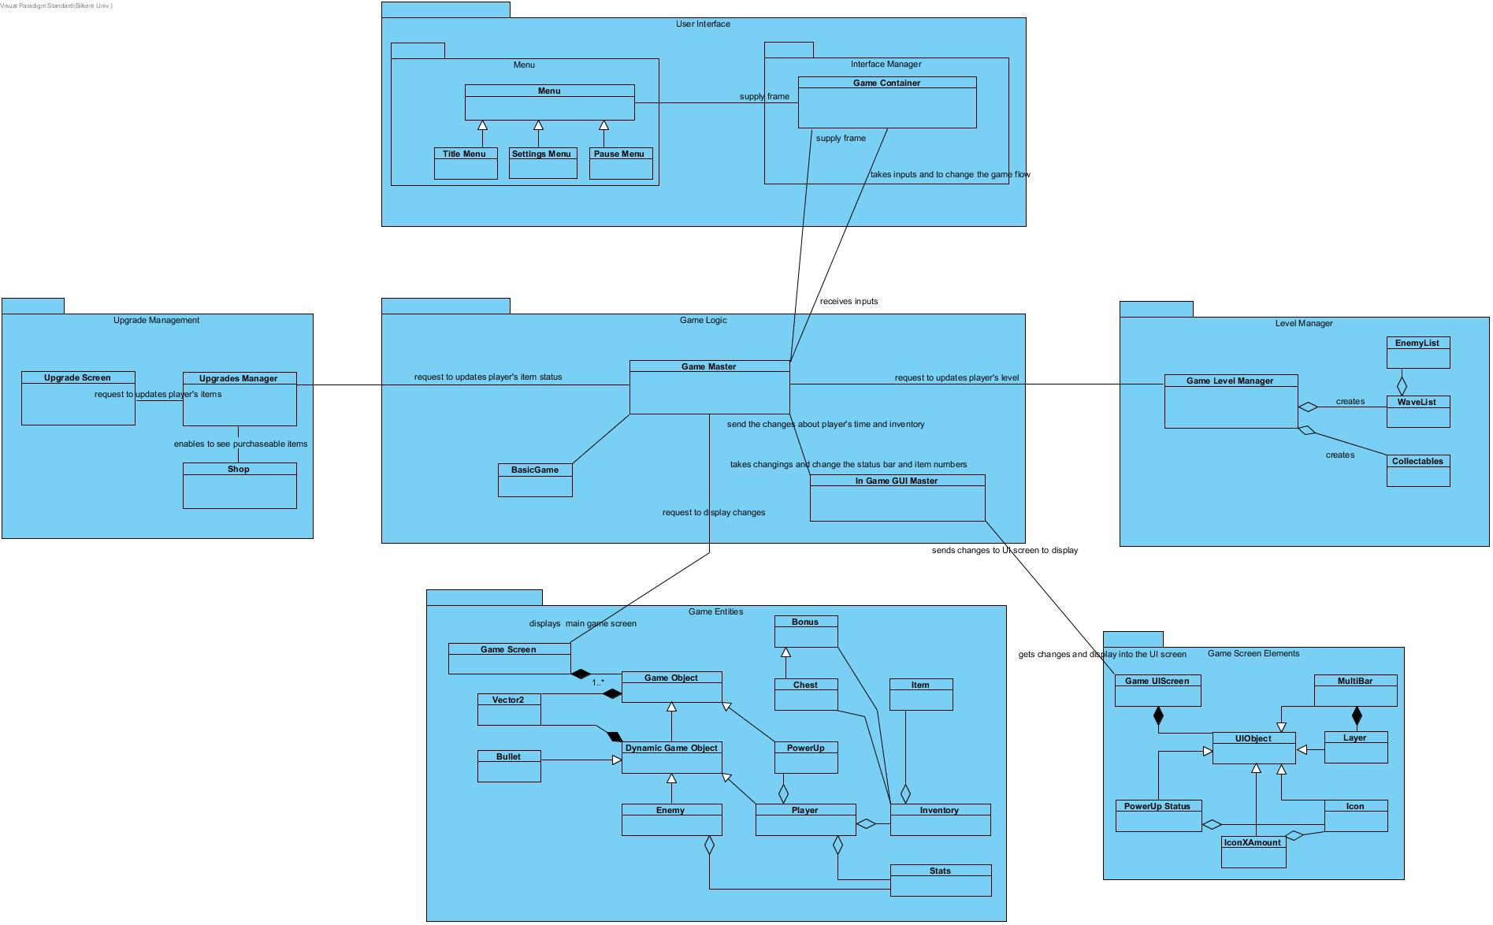

In the data tier, the third layer of the decomposition, utility classes will operate game entities and screen elements. Game Entities package contains the classes that are responsible for storing relevant information about objects in the game. Game Screen Elements, on the other hand, handles the In-Game User Interface that changes according to the actions occurring in the Game.

Relation Between Layer 2 and Layer 3

## **Hardware / Software Mapping**

Our game will require the Java Runtime Environment to be executed since it will be developed in Java. A keyboard and a mouse are required to play the game. In terms of graphical requirements of the program, we are planning to use Slick 2D graphics library. Average computer standards will be enough to handle the game.

## **Persistent Data Management**

Game data will be stored in the user’s local hard drive. Our game does not require any database system since the data that is used in the game need to be accessed in real time. Thus, all the necessary files and data will load onto the memory.

## **Boundary Condition**

The game will give an error if the file is corrupted and will delete its content. The game will return to the main menu if all lives of the player are gone. The game has a finite number of levels so if the player will be able to complete the game will return to the main menu again.

# **Subsystem Services**

## **Detailed Object Design**

The overall class diagram will provide a better understanding of the subsystem and classes inside the packages. With the help of this diagram, it will be easier to comprehend the design of our project.



## **User Interface Subsystem**

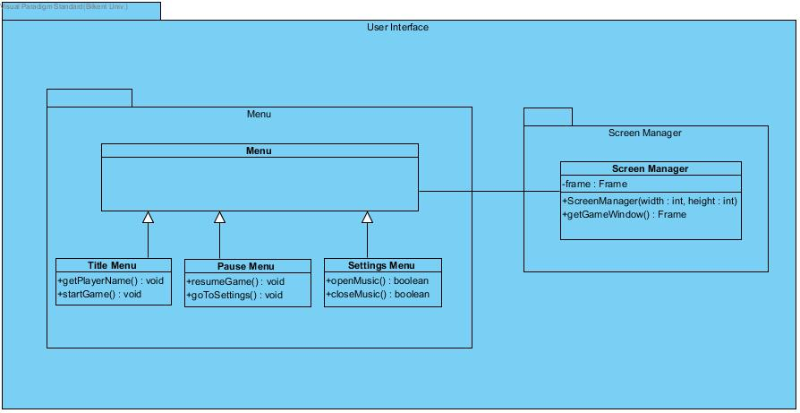

**Menu Class  
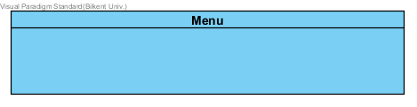**This class organizes Title Menu Class, Pause Menu Class, and Settings Menu Class. Each individual menu has the same contents with the “Menu” class, so having a parent class for other menus makes the hierarchical system easier to understand.

### **Title Menu Class**

### A simple title screen to start the game and let the player enter his/her name.

***Methods:*public void setPlayerName(String name):** This method gets the player’s name or nick-name. It takes a parameter ‘name’ and passes it to the player object.**public void startGame():** This method starts the game and opens the main game screen. It does not return anything.

### **Pause Menu Class**

### A simple pause menu can call settings or resumes the game.

### ***Methods:***

### **public void resumeGame():** Calls the Game master’s resumeGame() function of GameMaster. **public void goToSettings():** This method displays the setting menu to the user. It does not return anything.

**Setting Menu Class**

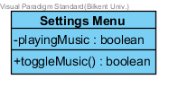

Settings menu allows the user to open or close the music sound.

***Attributes:***

**private Boolean playingMusic:** An indicator variable to hold if the game music is currently played or not.

***Methods:*   
public boolean toggleMusic():** This method starts playing the game music if it’s turned off or stops playing the music if its turned on. Returns true if music starts return false if it stops. It sets the playingMusic accordingly.

**Game Container Class**Library provided class that provides frames and input adapters.

## **3.3 Upgrade Management Subsystem**

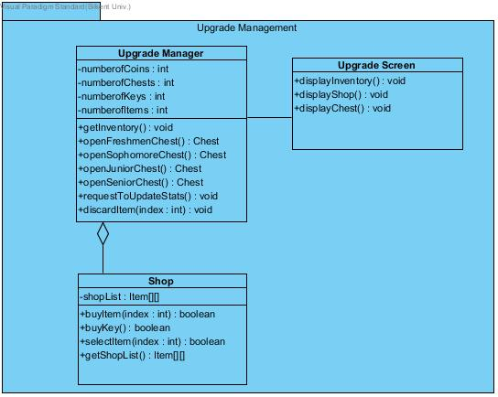

Upgrade Management Subsystem is one of the major subsystems in the design process. This subsystem includes Upgrade Manager, Upgrade Screen, and Shop classes. These classes have following functions;

* Upgrade Manager class handles the situation of player’s items.
* Upgrade Screen class displays the changes into the main screen.
* Shop class handles the purchase and removal of the items

**Upgrade Manager Class**

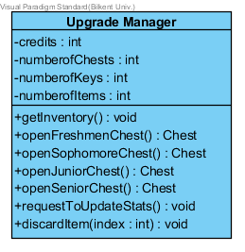

Upgrade Manager class is for the game upgrade system. After each level, the user enters an upgrade phase and this class manages that phase by holding values such as credits, number of chests, keys and items player has. Opening chests, stat upgrading and inventory management is done by this class as well.  
 ***Attributes:*   
private int credits**: It keeps the coin number that user has.  
**private intnumberOfChests:** It keeps the chest number that user has.  
**private intnumberOfKeys**: It keeps the key number that user has.

***Methods:*public Inventory getInventory():** This method gets player’s inventory object.**public Item openFreshmenChest():** This method opens freshmen type of chest. To open freshmen chest, it requires 1 key. It has 90% chance of giving a standard tier item, 7% chance of giving a rare tier item and 3% chance of giving an ultra-rare tier item. Therefore, according to these possibilities, this method fetches the item and returns it. Also decrements the key and the chest amounts from player’s inventory accordingly.

**public Item openSophomoreChest():** This method opens a sophomore type of chest. To open the sophomore chest, it requires 2 keys. It has 50% chance of giving a standard tier item, 30% chance of giving a rare tier item and 20% chance of giving an ultra-rare tier item. Therefore, according to these possibilities, this method gives the item and returns it. Also decrements the key and the chest amounts from player’s inventory accordingly.**public Item openJuniorChest():** This method opens a junior type of chest. To open the junior chest, it requires 3 keys. It has 30% chance of giving a standard tier item, 35% chance of giving a rare tier item, 25% chance of giving an ultra-rare tier item and 10% chance of giving a “hacker” tier item. Therefore, according to these possibilities, this method gives the item and returns it. Also decrements the key and the chest amounts from player’s inventory accordingly.**public Item openSeniorChest():** This method opens a junior type of chest. To open the junior chest, it requires 3 key. It has 18% chance of giving a standard tier item, 25% chance of giving a rare tier item, 32% chance of giving an ultra-rare tier item and 25% chance of giving a “hacker” tier item. Therefore, according to these possibilities, this method gives the item and returns it. Also decrements the key and the chest amounts from player’s inventory accordingly.**public void requestToUpdateStats():** This method sends an update request to game master in order to update the player’s stats or game flow. It does not return anything.**public boolean discardItem(int index):** This method removes the item that is given in the index of the player’s inventory and returns true if removal is successful or false if it fails.

**Upgrade Screen Class**

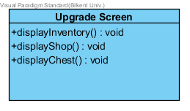

This class is basically for displaying the upgrade phase to the player. The player should be able to see his/her inventory, the shop and chests to be able to tell what to buy or discard or which chest to open or not. ***Methods:*public void displayInventory():** This method displays the inventory of the player on the screen by iterating over the list of items, number of chests and keys. It does not return anything.**public void displayShop():** This method displays the shop on the screen in order to show the purchasable items from the shop by iterating over the shop’s item list. It does not return anything.

**Shop Class**

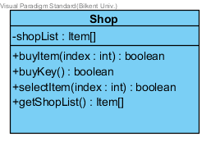

Shop class has an attribute, a shop list which is an array of items that are sold in the shop. With this class, the player will be able to do the operations that should be done in a shop system; buy, select or get the item list of the shop. ***Attributes:*   
private Item[] shopList:** It keeps the shop items into the one-dimensional array.

***Methods:*public boolean buyItem(index: item**): This method buys the item and it returns true if the item is successfully bought or false if the item is not bought.**public boolean buyKey():** This method buys the key in order to open a chest and it returns true if the key is successfully bought or false if the key is not bought.**public Item[] getShopList():** This method gets the shop item’s list and returns them.

## **3.4 Level Manager SubsystemLevel manager**

Level Manager subsystem is used to create each level that player encounters. Every level has different components and elements which are being read from a text file and integrated into levels. Each class of Level Manager subsystem will be explained in detail in this section.

**GameLevelManager Class**

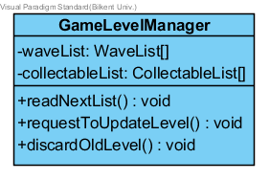

Reads the level’s or game specification from a text file then constructs a waveList that contains waves which contain lists of enemies.

***Attributes:*private WaveList[] waveList:** it is an instance of WaveList class and used for connecting waveList class with the GameLevelManager. **private CollectableList[] collectableList:** it is an instance of CollectableList class and used for connecting CollectableList class with the GameLevelManager.

***Methods:*public void readNextList():** This method is used for reading from a text file to get the lists of objects. It used Java’s FileReader method.**public void requestToUpdateLevel():** This method is for requesting to update the level from the GameMaster class in the GameLogic subsystem.**public void discardOldLevel():** This method discards the level when the user completes or fails to complete a level.

**Wave Class**

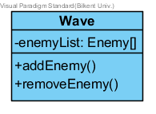

Wave Class holds a list of enemies that are specified by GameLevelManager. Waves hold an array of Enemy objects and their stats. Enemy objects can be added or removed from waves.  
***Attributes:***   
**private Enemy[] enemyList:** This attribute is a list of Enemy objects.

***Methods:*public void addEnemy():** Adds an enemy object to the list.**public void removeEnemy():** Removes an enemy object from the list.

**WaveList Class**

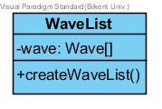

Holds a list of Waves, which was the previous class explained.  
***Attributes:***   
**private Wave[] wave:** This attribute is a list of Wave objects.  
***Methods:*public void createWaveList():** Creates the Enemy objects to the list.

**CollectableList Class**

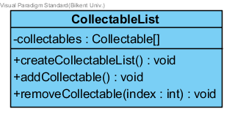

Holds the collectibles that will be instantiated during game play by GameMaster. ***Attributes:*private Collectable[] collectibles:** This attribute is a list of Collectable objects.

***Methods:*public void createCollectableList():** creates and assigns the list of Collectables via random selection. The resulting list is assigned to collectibles.  
**public void addCollectable():** Adds a collectible object to the list.**public void removeCollectable(int: index):** Removes a collectible object from the list in the given index.

## **Game Logic Subsystem**

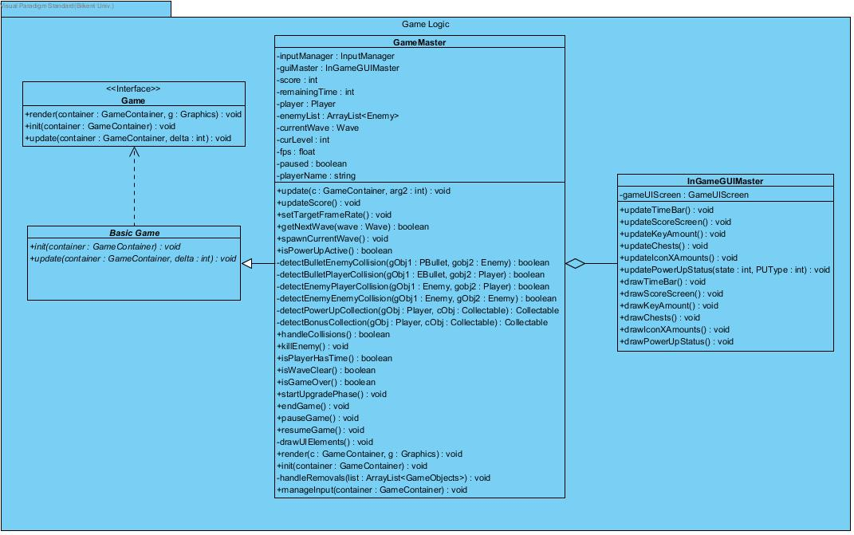

In the Game Logic subsystem, our controller objects are grouped together to manage the actual game dynamics and game logic. We have GameMaster, InGameGUIMaster, and BasicGame. These classes are explained in detail, in this section. The base idea is to have a **centralized control**.

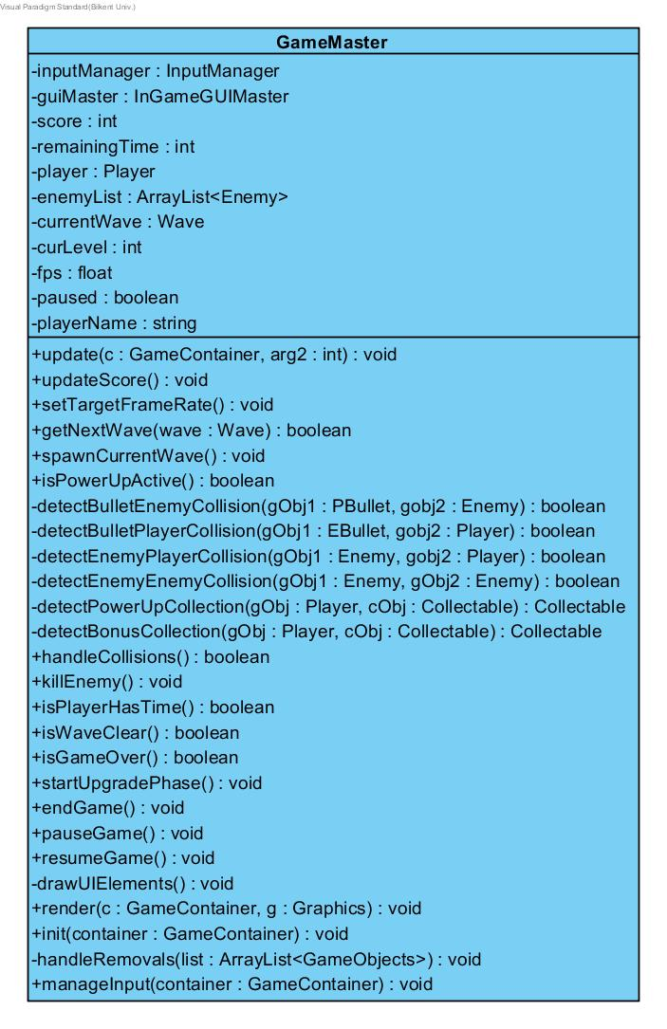**GameMaster Class**

GameMaster class is the control object of the Game Logic subsystem, it performs the proper operations according to the requests that came from User Interface subsystem, and also this class runs the game in a loop. This class implements **centralized control**. (That’s why it has so many methods.)

***Attributes:*private InputManager inputManager:** this attribute is used for detecting user actions in the game.**private InGameGUIMaster guiMaster:** this attribute is used for updating graphical user interface on the game screen.**private int score:** it is used for player’s score to represent the success in the game.**private int remainingTime:** it is used for determining the game time representing both real-time and player’s health.**private Player player:** this attribute initializes a player object to use in the game.**private ArrayList<Enemy>enemyLists:** this attribute initialize enemy list taking from the level subsystem.**private Wave currentWave:** this attribute initialize a wave of the enemy by taking the enemy list when the player killed them**private int curLevel:** this attribute holds the which level is called.**private float fps:** this attribute takes the frame per second to determine the movements of game objects.  
**private boolean pause**: this attribute is used for whether the game is paused or not.  
**private String playerName:** holds the name that system acquired from the player in the title screen.

***Methods:***

**public void update(c: GameContainer, arg2, int):** runs a loop in which all system components are updated continuously until the breakpoints (such as pause, game over, or finish game). Checks if the wave is cleared, using isWaveClear method and calls getNextWave and spawnCurrentWave accordingly.  
**public void updateScore():** updates the score of the player if it successfully kills an enemy.  
**public void setTargetFrameRate():** holds the average frame per second until the 30.  
**public Boolean getNextWave(wave: Wave):** calls the new wave of enemies when all enemies in the previous wave are killed by the player.  
**public void spawnCurrentWave() :** if getNextWave is true, this method creates current wave enemies.  
**public Boolean isPowerUpActive():** checks whether the player has activated any power-ups or not.  
**public Boolean detectBulletEnemyCollision(gObj1: PBullet, gobj2: Enemy):** detects the Player Bullet and Enemy collision, in this type collision enemy takes damage and its health decreases. After the collision, bullet disappears.  
**public Boolean detectBulletPlayerCollision(gObj1: EBullet, gobj2: Player):** detects the Enemy Bullet and Player collision, in this type collision player takes damage and its health decreases. After the collision, bullet disappears.  
**public Boolean detectEnemyPlayerCollision(gObj1: Enemy, gobj2: Player):** detects the Enemy and Player collision, in this type collision both enemy and player takes damage and their health decreases.  
**public Boolean detectEnemyEnemyCollision(gObj1: Enemy, gObj2: Enemy):** detects the Enemy and Enemy collision, in this type collision both enemies hits and removes each other without any damages.  
**public Collectable detectPowerUpCollection(gObj : Player, cObj : Collectable):** detects the Player and Power-ups collision. After the collision, the player takes the power up and isPowerUpActiveis returned true. And also, the power up disappears on the game arena then it goes to the power-up box on the corner of the game screen to be used later in the game.  
**public Collectable detectBonusCollection(gObj : Player, cObj : Collectable):** detects the Player and collectable item(key, chest or coin) collisions. After the collision player takes the items and one of these InGameGUIMsster methods (updateKeyAmount, updateChests, updateIconXAmounts) is called and this item is added player’s inventory. And also, the item disappears into the game arena.  
**public Boolean handleCollision():** checks any collision, if there is any call the detectCollision methods and return true, else return false.  
**public void killEnemy():** changes the death-flag to true if the enemy has no life.  
**public Boolean isPlayerHasTime():** checks whether the player has the time or not. If the time is over then returns false, otherwise, returns true.  
**public boolean isWaveClear():** checks if the current wave is cleared by the player.  
**public boolean isGameOver():** checks the player has enough time (if isPlayerHasTime is true) or not. This method returns true if isPlayerHasTime is false, otherwise, returns false.  
**public void startUpgradePhase():** before each level, this method is called and upgrade screen appears.  
**public void endGame():** exits the game when the player presses the “exit the game” button.  
**public void pauseGame():** pauses the game and call the pause screen when the player presses the pause button.  
**public void resumeGame():** resumes the game and closes pause screen.  
**public void drawUIElements():**gives the command to draw UI elements to inGameGUIMaster  
**public void render (c:GameContainer, g: Graphics):** draws game objects (player, enemies, bullets, collectibles) while iterating over the certain game object lists.  
**public void init(container: GameContainer):** constructs the player, initializes enemyList, bulletList, collectableList and sets current wave using getNextWave and spawnCurrentWave methods.  
**public void handleRemovals(list: ArrayList<GameObjects>):** checks death-flags of all enemies and removes them if the flags are true.**public void manageInput(container:GameContainer):** takes user inputs using GameContainer class

**Game Interface**

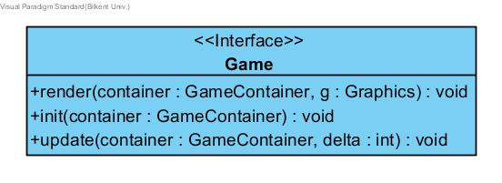

A library provided the interface. The main game interface that should be implemented by any game being developed using the container system. There will be some utility type sub-classes as development continues. [1]

**BasicGame Class**

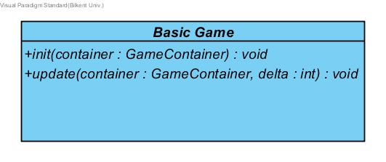  
A library provided class. BasicGame class is a basic implementation of a game to take out the boring bits.[2]

**InGameGUIMaster Class**

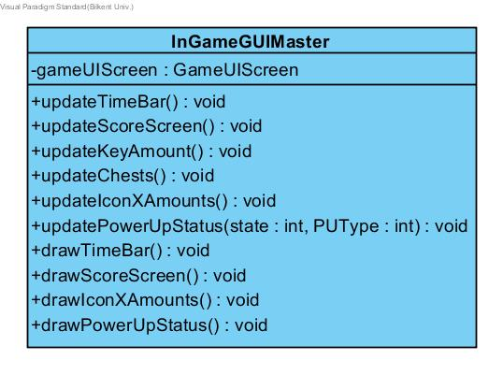

***Attributes:*private GameUIScreengameUIScreen:** User Interface screen for the in-game GUI. It allows the connection between the Game Screen Elements package’s GameUIScreen class and Game Logic package’s InGameGUIMaster.

***Methods:*public void updateTimeBar():** Updates the time bar of the player depending on the events occurring in the Game Master.  
**public void updateScoreScreen():** Updates the score screen in the game depending on the player’s score collection taken from the Game Master.  
**public void updateKeyAmount():** Updates a number of keys in the game depending on the Level Manager’s Collectables class.  
**public void updateChests():** Updates the chests in the game depending on the Level Manager’s Collectables class.  
**public void updateIconXAmounts():** Updates the number of Items (Number X “Icon of Object”) in the user’s inventory.

**public void updatePowerUpStatus(state: int, PUType: int):** Updates the current PowerUp icon on the screen by taking its states and types.  
**public void drawTimeBar():** draws the time bar using graphics.  
**public void drawScoreScreen():** draws the score screen using graphics.  
**public void drawIconXAmounts():** draws the number of items (number X) in the user’s inventory.   
**public void drawPowerUpStatus():** draws the powerup status on the right bottom corner of the screen.

## **Game Screen Elements Subsystem**

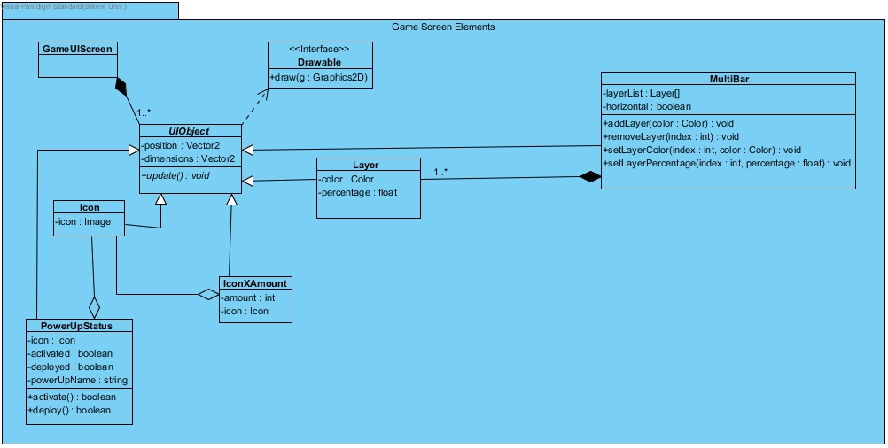

Game Screen Elements subsystem is used for creating in game user interface elements and updating them accordingly if necessary.

**GameUIScreen Class**

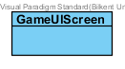It holds the list of UI Objects.

**Icon Class**

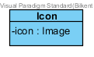Icon class holds an icon to use in the game.  
***Attributes:*  
private Image icon**: It holds an image of the icons.

**UIObject Class**

***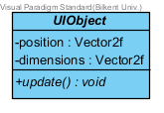*  
*Attributes:*  
private Vector2f position**: It keeps the position of the objects. **private Vector2f dimensions**: It keeps the size of the objects.  
***Methods:*public void update()**: It updates the position and the state of the object in every game loop. This method does not return anything.

**PowerUpStatus Class**

***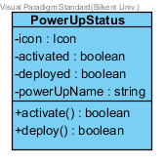*  
*Attributes:*  
private Icon icon**: It holds an icon of the power-ups.  
**private boolean activated**: It holds whether the power-up is activated or not.  
**private boolean deployed**: It holds whether the power-up is activated or not.  
**private string powerUpName**: It holds power up’s name.

***Methods:*public booleanactivate():** This method activates the power up and it returns whether the power-up is activated or not.  
**public boolean deploy():** This method deploys the power up and it returns whether the power-up is deployed or not.

**IconXAmount Class**

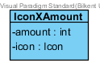

IconXAmount is the class that is used to display icon and the amount of a specific inventory statistic. That is, it shows how many of one specific item is in the possession of the player. It is another user interface element of the game.  
***Attributes:*  
private Icon icon:** It holds an icon the items.  
**private int amount:** It holds an amount of the items.

**Layer Class**

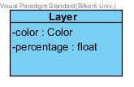

Layer class is for the multiBar component of the game. This is simply a rectangular graphical box that scales itself according to a percentage.  ***Attributes:*  
private Color color:** It holds a color of the layer.  
**private float percentage:** It holds a percentage of the layer.

**Multibar Class**

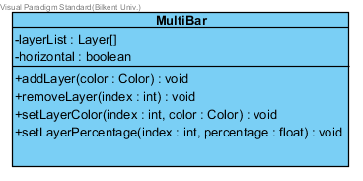

Multibar is a multi-purpose, multi-layered bar that displays health like statistics of an enemy or the player. Usually used for linearly decreasing or increasing statistics.   
 ***Attributes:*  
private Layer[] layerList:** It holds a list of the layer. **private boolean horizontal**: It holds the direction of the layer.  
***Methods:*public void addLayer(color: Color):** This method adds the new layer and it does not return anything.**public void removeLayer(Index: int):** This method removes the existing layer and it does not return anything.**public void setLayerColor(Index: int, color: Color**): This method sets the color of the existing layer and it does not return anything.**public float setLayerPercentage(Index: int, percentage: float):** This method sets the percentage of the existing layer and it returns the percentage.

## **3.7 Game Entities Package**C:\Users\Asus\AppData\Local\Microsoft\Windows\INetCache\Content.Word\Entity Subsystem Class Diagram Upgraded2.jpg

In the Game Entities Subsystem, our all game entity classes are grouped together with their relations. We have GameScreen, Vector2f, GameObject(abstract), DynamicGameObject(abstract), Stats, Enemy, Inventory, Player, Bullet, BouncyBullet, Final, Midterm, Quiz, Assignment, Lab, Bug,Chest, SeniorChest, JuniorChest, SaphomoreChest, FreshmenChest, Coin, Item, StandardItem, UltraRareItem, RareItem, HackerItem, Bonus, Key, PowerUp, ExtraTime, SlowTime, BouncyBullets, BulletBlast, DamageIncrease classes and Drawable, Shooter, Collectable interfaces. These classes and interfaces will be explained in detail, in this section.

**GameScreen Class**

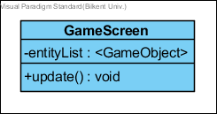

GameScreen class holds the game entities and upgrades them on the screen.  ***Attributes:***  
**private ArrayList<GameObject>entityList:** Holds the entity(GameObjects) objects of the game.

***Methods:*public void update():** calls the update method of every entity object.

**Drawable (interface)**

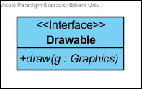

Drawable interface is provided for all game objects …

***Methods:*public void draw():** overridden by gameObjects a simple draw method to visualize objects.

**Vector2f1**

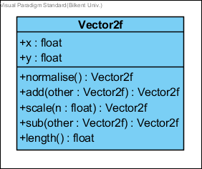  
A library provided representation of two-dimensional vectors[3]

**Shape2**

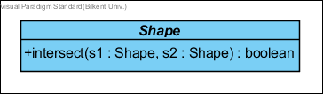

A library provided class. The description of any 2D shape that can be transformed. The points provided approximate the intent of the shape.  
***Attributes*public boolean intersect(Shape s1, Shape s2):** Check if this shape intersects with the other shape.

**GameObject Class (abstract)**

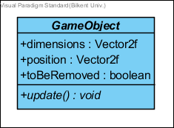

GameObject class is a base class for all entities in our game. ***Attributes:*public Vector2 dimensions:** rectangle sizes of a GameObject.**public Vector2 position:** thecenter position of a GameObject.  
**public boolean toBeRemoved:** it is a flag for GameMaster to check the object is to be removed or not before the next game cycle.

***Methods:***  
**public void update():** updates the information accordingly to the internal commands.

**DynamicGameObject (Abstract)**

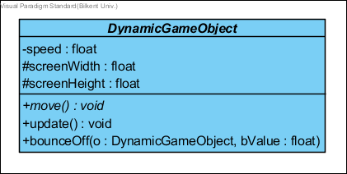

DynamicGameObject class is an abstract class for all movable game objects.

***Attributes:***  
**private float speed:** is the current speed of the dynamic game object.  
**protected float screenWidth:** is the width of the screen window in pixels.  
**protected float screenHeight:** is the height of the screen window in pixels.

***Methods:*private void move():** updates the location by speed.  
**private void update():** It updates the position and the state of the object in every game loop. This method does not return anything.  
**private bounceOff(DynamicGaneObject object, float bounceValue):** This method is to separate to colliding the dynamic game object by setting their positions to bounce Value away from each other. This simply gives them visualization of two game object bouncing from each other. This is usually called when two objects collide.

**Stats Class**

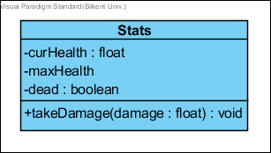

Stats class holds the variables about the health status of Player and Enemy objects.

***Attributes:*  
private float curHealth:** is the current health of game object(Player or Enemy). **private float maxHealth:** is the maximum health of game object(Player or Enemy).  
**private boolean dead():** is a flag value for removal from the gameScreen.

***Methods:*  
public void takeDamage(float damage):** decrements the curHealth by damage value. It controls the dead flag is true or not by checking curHealt is less than zero.

**Shooter(interface)  
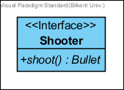**

Shooter is an interface for every shooting game object.

***Methods:*  
public Bullet shoot():** An abstract shoot method for shooting player and enemies.

**Enemy Class**

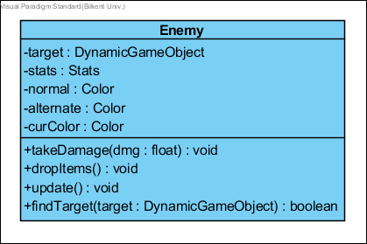

This class constructs the Enemy in our game. The enemy class is a parent class of all enemy types which are Final, Quiz, Midterm, Assignment, Lab, and Bug.

***Attributes:*  
private DynamicGameObject target:** the target of the enemy which will be attacked and possibly damaged. **private Stats stats:** stats objects for the enemy.  
**private Color normal:** it is a color when the object is initially created.  **private Color alternate:** it is a temporary color when the game object takes damage. **private Color curColor:**it is a current color of the game object.

***Methods:*  
public void takeDamage(float dmg):** calls the enemy’s stat objects, the amount of Damage that will be applied to Enemy if enemy is killed it will be marked for removal.(calls stats.takeDamage(dmg)) **public void dropItems():** Enemy drops items before getting removed because of death.  
**public void update():** It updates the position and the state of the object in every game loop. This method does not return anything. **public boolean findTarget(DynamicGameObject target):** Enemy seeks player as a target.

**Inventory Class**

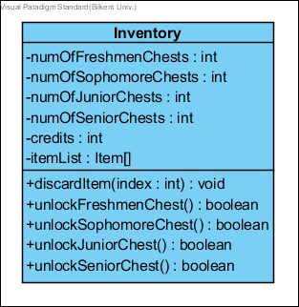

Inventory class is to hold the credits, the number of chests, and most importantly the list of items.

***Attributes:*  
private intnumOfFreshmenChests:** the number of chests of type ‘freshmen’ which are collected and not opened.  
**private intnumOfSophomoreChests:** the number of chests of type ‘sophomore’ which are collected and not opened. **private intnumOfJuniorChests:** the number of chests of type ‘junior’ which are collected and not opened. **private intnumOfSeniorChests:** the number of chests of type ‘senior’ which are collected and not opened. **private intcredits:** number of coins collected. **private Item[] itemList:** 5 items that are owned by the player.

***Methods:*  
public void discardItem(intindex):** removes the item at the given index. **public booleanFreshmenChest():** instantiates and opens a freshmenChest. **public booleanSophomoreChest():** instantiates and opens a SophomoreChest. **public booleanJuniorChest():** instantiates and opens a JuniorChest. **public booleanSeniorChest():** instantiates and opens a SeniorChest.

**Player Class**

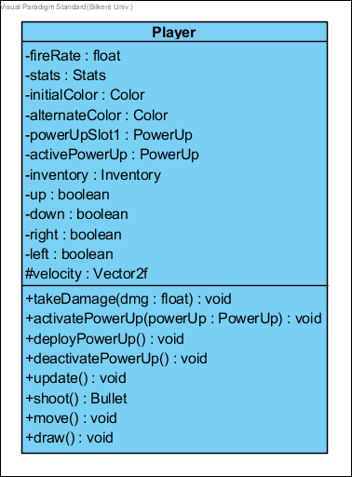Player controlled the game object which can move and shoot. ***Attributes:*  
private float fireRate:** To control the density of bullets.  
**private Stats stats:** players stats as a Stats object.  
**private ColorinitialColor:** color variable supplied for a drawn method to indicate player objects state changes.  
**private ColoralternateColor:** alternating color variable from the initial color  
**private PowerUp powerUpSlot1:** holds the primary and only(unless there is an item that specifies an extra slot) power up.  
**private PowerUpactivePowerUp:** holds a reference to an active power-up since there might be another one supplied by an item.  
**private Inventory inventory:** player’s inventory that holds items and num of chests keys credits…  
**private boolean up:** The variable to indicate the direction of upwards movement that is supplied by user input(via GameMaster).  
**private boolean down:** The variable to indicate the direction of downwards movement that is supplied by user input(via GameMaster).  
**private boolean right:** The variable to indicate the direction of rightwards movement that is supplied by user input(via GameMaster).  
**private boolean left:** The variable to indicate the direction of leftwards movement that is supplied by user input(via GameMaster).  
**protected Vector2f velocity:** the amount of velocity that player has**.**  
***Methods:*  
public void takeDamage(float dmg):** the amount of Damage that will be applied to Player if player is killed it will be marked for removal.(calls stats.takeDamage(dmg))  
**public void activatePowerUp(PowerUppowerUp):** activates the powerup specified in the parameter.  
**public void deployPowerUp():** deploys the activated powerUp.(calls activePowerUp.deploy()).  
**public void deactivatePowerUp():** deactivates the active power up.  
**public void update():** It updates the position and the state of the object in every game loop. This method does not return anything.  
**public Bullet shoot():** It shoots bullets with heavy damage.  
**public void draw():** It draws the shape of the superclass gameObject using dimension and position vectors with Graphics. This method does not return anything.  
**public void move():** It moves towards the target position which is a DynamicGameObject(usually the player) until it crashes and collides the target.

**Bullet Class**

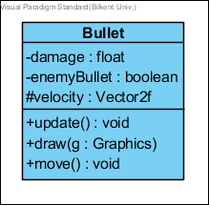

This class constructs the Bulletobject. ***Attributes:*private float damage:** the amount of damage to be applied to the collided enemy.  
**private boolean enemyBullet: t**he boolean variable that If it is shot by the enemy it is true, If it is shot by the player it if false.  
**protected Vector2f velocity:** the amount of velocity that bullet has**.**

***Methods:*public void update():** It updates the position and the state of the object in every game loop. This method does not return anything.  
**public void draw(Graphics g):** It draws the shape of the superclass gameObject using dimension and position vectors with Graphics. This method does not return anything.  
**public void move():** It moves towards the target position which is a DynamicGameObject(usually the player) until it crashes and collides the target.

**BouncyBullet Class**

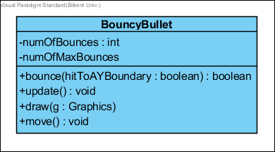

This class constructs the BouncyBulletobject.

***Attributes:*private intnumOfBounces:** counter for collisions with game Arena borders.**privateintnumOfMaxBounces:** max number of bounces for a bullet.

***Methods:*public boolean bounce (booleanhitToAYBoundary):** First checks if numOfBounces<=macNumOfBounces then it inverts the bouncy bullet’s velocity’s x value if the parameter is false else it inverts y value.   
**public void update():** It updates the position and the state of the object in every game loop. This method does not return anything. **public void draw(Graphics g):** It draws the shape of the superclass gameObject using dimension and position vectors with Graphics. This method does not return anything. **public void move():**It moves towards the target position which is a DynamicGameObject(usually the player) until it crashes and collides the target.

**Final Class**

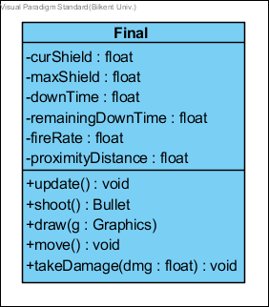

This class constructs the Finalobject.

***Attributes:*private float curShield:** holds the current value of the shield.  
**private float maxShield:** holds the maximum value of the shield.**private float downTime:** holds the initial value to be counted down from before the shield is back up.**private float remainingDownTime:** holds the countdown time for shields to be back up.**private float fireRate:** To control the density of bullets.  
**private float proximityDistance:** The minimum distance between final and the player since this enemy shoots. It does not attack the player by crashing. This value indicates how close can the final get to the player.

***Methods:***  
**public void update():** It updates the position and the state of the object in every game loop. This method does not return anything. **public Bullet shoot():** It shoots bullets with more heavy damage. **public void draw(Graphics g):** It draws the shape of the superclass gameObject using dimension and position vectors with Graphics. This method does not return anything. **public void move():** It moves towards the target position which is a DynamicGameObject(usually the player) until it crashes and collides the target. **public void takeDamage(float dmg):** Calls the enemy’s stat objects take damage method which substracts given float value(the parameter) from the current health.

**Midterm Class**

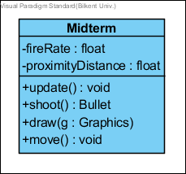

This class constructs the Midtermobject.

***Attributes:*private float fireRate:** To control the density of bullets.  
**private float proximityDistance:** The minimum distance between midterm and the player since this enemy shoots. It does not attack the player by crashing. This value indicates how close can the midterm get to the player.

***Methods:***  
**public void update():** It updates the position and the state of the object in every game loop. This method does not return anything. **public Bullet shoot():** It shoots bullets with heavy damage. **public void draw(Graphics g):** It draws the shape of the superclass gameObject using dimension and position vectors with Graphics. This method does not return anything. **public void move():** It moves towards the target position which is a DynamicGameObject(usually the player) until it crashes and collides the target.

**Quiz Class**

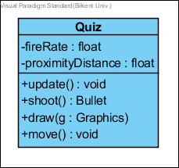

This class constructs the Quizobject.

***Attributes:*private float fireRate:** To control the density of bullets.  
**private float proximityDistance:** The minimum distance between quiz and the player since this enemy shoots. It does not attack the player by crashing. This value indicates how close can the quiz get to the player.

***Methods:***  
**public void update():** It updates the position and the state of the object in every game loop. This method does not return anything. **public Bullet shoot():** It shoots bullets with average damage. **public void draw(Graphics g):** It draws the shape of the superclass gameObject using dimension and position vectors with Graphics. This method does not return anything. **public void move():** It moves towards the target position which is a DynamicGameObject(usually the player) until it crashes and collides the target.

**Assignment Class**

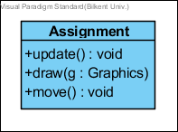

This class constructs the Assignmentobject.

***Methods:***  
**public void update():** It updates the position and the state of the object in every game loop. This method does not return anything. **public void draw(Graphics g):** It draws the shape of the superclass gameObject using dimension and position vectors with Graphics. This method does not return anything. **public void move():** It moves towards the target position which is a DynamicGameObject(usually the player) until it crashes and collides the target.

**Lab Class**

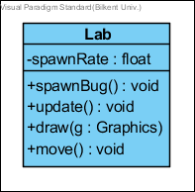

This class constructs the Lab object.

***Attributes:*private float spawnRate:** To control the density of “bug” objects spawned by the lab.

***Methods:*public spawnBug():** spawns bugs to attack player  
**public void update():** It updates the position and the state of the object in every game loop. This method does not return anything. **public void draw(Graphics g):** It draws the shape of the superclass gameObject using dimension and position vectors with Graphics. This method does not return anything. **public void move():** It moves towards the target position which is a DynamicGameObject(usually the player) until it crashes and collides the target.

**Bug Class**

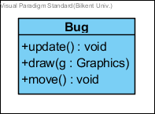

This class constructs the Bug object.

***Methods:***  
**public void update():** It updates the position and the state of the object in every game loop. This method does not return anything.  
**public void draw(Graphics g):** It draws the shape of the superclass gameObject using dimension and position vectors with Graphics. In case of Bug, this simply draws a green square with the given dimension and position.  
**public void move():** It moves towards the target position which is a DynamicGameObject(usually the player) until it crashes and collides the target.

**Chest Class**



This class constructs the chests. Chest Class is a parent class and has four children classes are Freshmen Chest, Sophomore Chest, Junior Chest, and Senior Chest. ***Attributes:*  
private int numOfKeysNeed**: It holds a number of the keys needed.

***Methods:*public boolean unlock():** This method unlocks the chest and it returns whether the chest is unlocked or not.  
**public void update():** It updates the position and the state of the object in every game loop. This method does not return anything.

**Freshmen Chest Class**

****This class constructs the freshmen chest object.

***Methods:***

**public boolean collect() :** It collects the item. This method returns true if it collected the item otherwise returns false. It adds the power up to the player power up.

**public void update():** It updates the position and the state of the object in every game loop. This method does not return anything.

**public void draw(Graphics g):** It draws the shape of the superclass gameObject using dimension and position vectors with Graphics. This method does not return anything.

**public Item unlock():** It opens the chest object. It has 90% chance of giving a standard tier item, 7% chance of giving a rare tier item and 3% chance of giving an ultra-rare tier item.

**Sophomore Chest Class**

****This class constructs the sophomorechest object.

***Methods:***

**public boolean collect() :** It collects the item. This method returns true if it collected the item otherwise returns false. It adds the power up to the player power up.   
**public void update():** It updates the position and the state of the object in every game loop. This method does not return anything.  
**public void draw(Graphics g):** It draws the shape of the superclass gameObject using dimension and position vectors with Graphics. This method does not return anything.  
**public Item unlock():** It opens the chest object. It has 50% chance of giving a standard tier item, 30% chance of giving a rare tier item and 20% chance of giving an ultra-rare tier item.

**Junior Chest Class**

****This class constructs the junior chest object.

***Methods:***

**public boolean collect():** It collects the item. This method returns true if it collected the item otherwise returns false. It adds the power up to the player power up.   
**public void update():** It updates the position and the state of the object in every game loop. This method does not return anything.  
**public void draw(Graphics g):** It draws the shape of the superclass gameObject using dimension and position vectors with Graphics. This method does not return anything.  
**public Item unlock():** It opens the chest object. It has 30% chance of giving a standard tier item, 35% chance of giving a rare tier item, 25% chance of giving an ultra-rare tier item, 10% chance of giving a “hacker” tier item.

**Senior Chest Class**

****This class constructs the senior chest object.

***Methods:***

**public boolean collect():** It collects the item. This method returns true if it collected the item otherwise returns false. It adds the power up to the player power up.   
**public void update():** It updates the position and the state of the object in every game loop. This method does not return anything.  
**public void draw(Graphics g):** It draws the shape of the superclass gameObject using dimension and position vectors with Graphics. This method does not return anything.  
**public Item unlock():** It opens the chest object. It has 18% chance of giving a standard tier item, 25% chance of giving a rare tier item, 32% chance of giving an ultra-rare tier item, 25% chance of giving a “hacker” tier item.

**Coin Class**



This class constructs the coin object. ***Attributes:***

**Private int value:** It holds a number of coins.

***Methods:***

**public boolean collect():** It collects the item. This method returns true if it collected the item otherwise returns false. It adds the power up to the player power up.   
**public void update():** It updates the position and the state of the object in every game loop. This method does not return anything.  
**public void draw(Graphics g):** It draws the shape of the superclass gameObject using dimension and position vectors with Graphics. This method does not return anything.

**Item Class**



This class constructs the items. Item Class is a parent class and have three children classes are Standard Item, Ultra Rare Item, Hacker Item, and Rare Item.

***Attributes:***

**private int cost**: It holds the cost of the item.  
**private String name :** It holds the name of the item.  
**private String description:** It holds the description of the item.

***Methods:***

**Public void affect():** It sends the effect to the game master.

**Standard Item Class**

****This class constructs the standard items

**Ultra Rare Item Class**

****This class constructs the ultra-rare items

**Rare Item Class**

****This class constructs the rare items

**Hacker Item Class**

****This class constructs the hacker items.

**Collectable Interface**



Collectable is an interface for all collectible items in the game. These are Bonus and PowerUps.

***Methods:***

**public boolean collect():** is called when the player collides any Collectable items in the game.

**Bonus Class**



Bonus Class is a parent class and have three children classes are Chest, Coin, and Key.

***Attributes:***

**private Boolean pickedUp:** is determine whether the Bonus item is picked up by player or not.

***Methods:***

**public void update() :** It updates the position and the state of the object in every game loop. This method does not return anything.

**Key Class**



This class constructs the key.

***Attributes:***

**private float duration:** It is specified the duration of existence of a key in the game.   
**private float remainingTime:** It is specified the remaining time from the duration of the key.

***Methods:***

**public boolean collect():** It collects the item. This method returns true if it collected the item otherwise returns false. It adds the power up to the player power up.   
**public void update():** It updates the position and the state of the object in every game loop. This method does not return anything.  
**public void draw(Graphics g):** It draws the shape of the superclass gameObject using dimension and position vectors with Graphics. This method does not return anything.

**PowerUp Class**



PoverUp Class is a parent class and has five children classes are ExtraTime, SlowTime, BouncyBullets, BulletBlast, and DamageIncrese.

***Attributes:***

**private boolean active:** it specifies whether the power-up is active or not.  
**private float duration:** it specifies the duration of existence of power-up in the game.   
**private float pickedUp:** it specifies whether the power-up is picked-up by player or not

***Methods:***

**public void deploy():** this method deploys the power-up when the player collides power-up to use in the game.  
**public void update():** It updates the position and the state of the object in every game loop. This method does not return anything.

**ExtraTime Class**



ExtraTime Class adds the extra time to player’s game-time

***Attributes:***

**private float amount:** it specifies the amount of time which is added to the player.

***Methods:***

**public boolean collect():** It collects the item. This method returns true if it collected the item otherwise returns false. It adds the power up to the player power up.   
**public void update():** It updates the position and the state of the object in every game loop. This method does not return anything.  
**public void draw(Graphics g):** It draws the shape of the superclass gameObject using dimension and position vectors with Graphics. This method does not return anything.

**SlowTime Class**



SlowTime Class slows the time for all game objects.

***Attributes:***

**private float multiplier:** it specifies the ratio of the slowing time.

***Methods:***

**public boolean collect() :** It collects the item. This method returns true if it collected the item otherwise returns false. It adds the power up to the player power up.   
**public void update():** It updates the position and the state of the object in every game loop. This method does not return anything.  
**public void draw(Graphics g):** It draws the shape of the superclass gameObject using dimension and position vectors with Graphics. This method does not return anything.

**BouncyBullets Class**



BouncyBullets Class replaces the bullets with the bouncy bullets which bounce off (3 times per bullet) from the borders of the game are instead of simply going out.

***Methods:***

**public boolean collect():** It collects the item. This method returns true if it collected the item otherwise returns false. It adds the power up to the player power up.   
**public void update():** It updates the position and the state of the object in every game loop. This method does not return anything.  
**public void draw(Graphics g):** It draws the shape of the superclass gameObject using dimension and position vectors with Graphics. This method does not return anything.

**BulletBlast Class**



BulletBlast Class sends out a circular group of bullets originating from the player.

***Methods:***

**public boolean collect():** It collects the item. This method returns true if it collected the item otherwise returns false. It adds the power up to the player power up.   
**public void update():** It updates the position and the state of the object in every game loop. This method does not return anything.  
**public void draw(Graphics g):** It draws the shape of the superclass gameObject using dimension and position vectors with Graphics. This method does not return anything.

**DamageIncrease Class**



DamageIncrease Class makes Player’s bullets harder for 5 seconds.

***Attributes:***

**private float multiplier:** it specifies the ratio of the increasing damage.

***Methods:***

**public boolean collect():** It collects the item. This method returns true if it collected the item otherwise returns false. It adds the power up to the player power up.   
**public void update():** It updates the position and the state of the object in every game loop. This method does not return anything.  
**public void draw(Graphics g):** It draws the shape of the superclass gameObject using dimension and position vectors with Graphics. This method does not return anything.

# Improvement Summary

We have made some rational changes in our project since iteration one. First of all, starting the implementation made a lot of classes clearer in our minds so we have added and removed so classes or some methods from our design. It was much easier to understand what was really necessary and what was not. So, this was definitely an improvement for our project.

As for the reports, we have learned from the feedback we got from the 1st iteration and add more explanation to every class we have. This made is easier for anyone that reads this design document and construct the project in their minds.

1. Slick2D Game Interface: <http://slick.ninjacave.com/javadoc/org/newdawn/slick/Game.html>
2. BasicGame class in Slick2D: <http://slick.ninjacave.com/javadoc/org/newdawn/slick/BasicGame.html>
3. In the feedback It was advised us to name our classes “**wisely**” although we switched libraries in between and this particular class is no more our implementation the name is roughly the same(It used to be Vector2 now Vector2f). We also would like to inform you that representing 2D points/Vectors in programming with the name “**Vector2**” is common convention.

   Here are some links to popular Game Engines and Java Game Libraries:

   Unity Engine **Vector2**: <https://docs.unity3d.com/ScriptReference/Vector2.html>

   Unreal Engine F**Vector2D**: <https://docs.unrealengine.com/latest/INT/API/Runtime/Core/Math/FVector2D/>

   Hero Engine(has only 3D vectors) **Vector**3: <http://hewiki.heroengine.com/wiki/Vector>

   Java Light Weight Game Library’s AI**Vector2D**: <https://javadoc.lwjgl.org/>

   Slick 2D’s **Vector2**f: <http://slick.ninjacave.com/javadoc/org/newdawn/slick/geom/Vector2f.html> (our library)

   2 <http://slick.ninjacave.com/javadoc/org/newdawn/slick/geom/Shape.html>